Université d’Ottawa
Faculté de genie

École d’ingénierie et de
technologies de l’information


University of Ottawa
Faculty of Engineering

School of Information
Technology and Engineering

CEG 4131 Computer Architecture III: FINAL EXAM

Date: December 14th | Professor: Dr. M. Bolic
Duration: 3 hours | Session: Fall 2007-2008
Total Points = 100

Note: Closed book exam. Calculators are allowed. No cheat-sheets.

Name: _______________________Student ID:_______________

Question | Maximum | Score
1 | 36
2 | 16
3 | 15
4 | 17
5 | 16
Total | 100
QUESTION #1 (3 points each, total 36)
Answer to the following questions

- How antidependencies and output dependencies affect execution of the code on superscalar processors? What technique is used to remove output and anti-dependencies? How are these dependencies removed?

- What are disadvantages of snoopy protocols and why do people use centralized protocols for resolving cache coherence issues?

- What is the reason for using Barrier in parallel programming? Please elaborate in at least two sentences.

- What is the difference between oblivious and adaptive routing in message passing systems?

- What is the virtual channel and what is it used for? Does the number of physical channels correspond to the number of virtual channels?

- If we compare a program that deals with arrays written for the vector and for the scalar processor, we can see that the vector program has the smaller number of instructions and it also executes the smaller number of operations. Why?

- What does “stride” mean in vector processor terminology?

- What is SPMD?

- What are burst transactions in buses? Why are they used?

- Describe the advantages of split transactions in buses?

- Define maximum and minimum values for speed-up and efficiency? Assume that the worst-case execution time of a parallel program is the same as the execution time of the sequential program.

- What is the diameter of a ring network with N nodes in case
    - it supports two-way communication
    - it supports only one-way communication

QUESTION #2: (8+8 = 16 Points)
Interconnection networks

a.
Consider simple comparison between 16x16 Omega network and 16x16 crossbar networks. While the crossbar uses cross points, the Omega network is using 2x2 switching elements (SE). Assume that the cost of the SE is four times that of a cross point. Which network is more expensive and how many times if we assume that the cost of the Omega network is determined only by its switching elements and the cost of the crossbar network is determined only by its cross points.

b. Draw a message passing system that allow for 8 processors to communicate among themselves using Omega network.

QUESTION #3 (total 15 points)
Shared memory systems

Consider a multiprocessor system with 2 processors (A and B) with their individual caches that are connected via a bus with a shared memory. Variable x is originally x=3. Given is the following sequence of operations:
- A reads variable x
- B reads variable x
- B updates x so that x=x+2
- A updates x so that x=x*2
- B reads variable x
Give the state of the cache controller and the contents of the caches and the memory (x) after each step, if
(a) two-state write-through write invalidate protocol is used (Figure 1).
(b) basic MSI write-back invalidation protocol is used (Figure 2).
(c) Full-mapped Centralized directory protocol

a) | State of A’s cache | Content of x in A’s cache | State of B’s cache | Content of x in B’s cache | Content of memory location x
- A reads variable x
- B reads variable x
- B updates x so that x=x+2
- A updates x so that x=x*2
- B reads variable x

b) | State of A’s cache | Content of x in A’s cache | State of B’s cache | Content of x in B’s cache | Content of memory location x
- A reads variable x
- B reads variable x
- B updates x so that x=x+2
- A updates x so that x=x*2
- B reads variable x

c) | Content of x in A’s cache | Content of x in B’s cache | Content of memory location x | Content of the directory
- A reads variable x
- B reads variable x
- B updates x so that x=x+2
- A updates x so that x=x*2
- B reads variable x

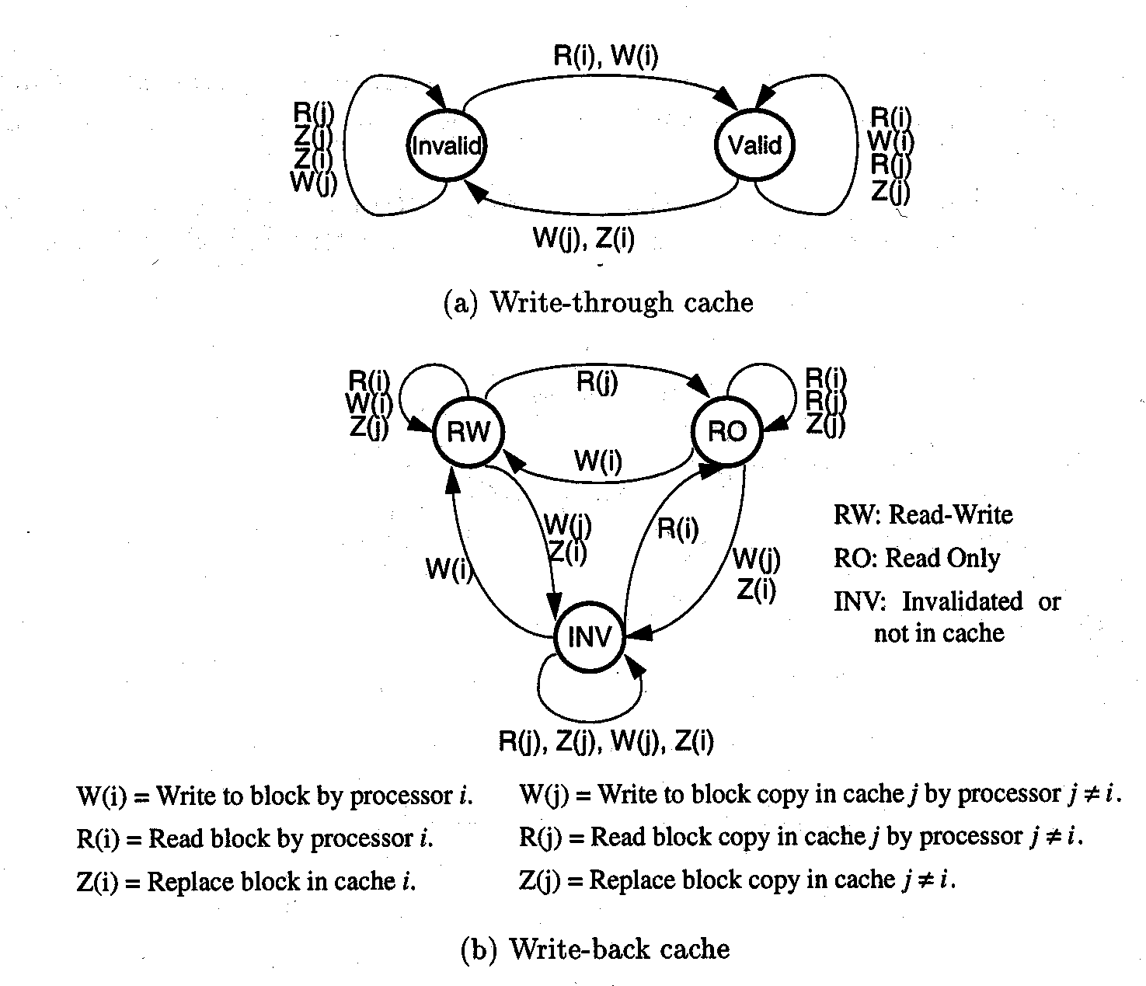
R = Read, W = Write, Z = Replace
i = local processor, j = other processor

Figure 1 State machine for write through write invalidate cache coherence protocol

Figure 2 State machine for write-back write invalidate cache coherence protocol

QUESTION #4 (a 7 points, b 5 points, c 5 points, total 17)

We have to perform parallel addition of M=128 integer numbers on N=4 processors. Assume that the interconnection network is built in a way that processors 1 and 2; 1 and 3; and 3 and 4 can communicate directly.
- Explain how the program for parallel addition would work.

b1) Assuming that addition takes 1 time unit and communication between processors 0 time units, draw the parallelism profile.
b2) What is the average parallelism? Will average parallelism increase if we increase the problem size M?

c1) Assume that addition takes 1 time unit and time to send and receive one integer number takes 2 time units. What is the speed-up and efficiency of this parallel system?
c2) Derive the expression for speedup when M numbers are added on N processors. Addition takes T1 time units and communication takes T2 time units.
QUESTION #5 (a, b 8 points each, total 16 points)

- Show graphically true, anti and output dependencies for the following code fragment.
- How long will this code fragment take to execute on an in-order superscalar processor with two execution units? Any execution unit can execute any instruction and the latency of all instructions is one cycle? Assume that the pipeline depth is 5 stages.

I1: LD r1, (r2)
I2: SUB r4, r5,r6
I3: ADD r3, r1, r7
I4: MUL r8, r3, r3
I5: ST (r11), r4
I6: ST (r9), r8
I7: ADD r15, r14, r10
I8: MUL r10, r15, r10
I9: ST (r9), r10

